Lab #12 B part

Task #5:

#include<iostream>

#include<string>

using namespace std;

int main()

{

char arr[13][6]; // character array of 13*6

int row_no = 1, seat_no; // Variable for displaying Row numbers

string seat_type; // variable that takes seat type

for (int i = 0; i < 13; i++) // for loop for assigning loop with *

{

for (int j = 0; j < 6; j++)

arr[i][j] = '*';

}

// disolaying initial information

cout << endl << endl << "Row No\t\t\t\t\t------------Plane Seat Reservation Program------------" << endl << endl;

for (int i = 0; i < 13; i++) // for loop thst display Seats

{

cout << row_no << "\t\t\t\t\t";

row_no++;

for (int j = 0; j < 6; j++)

{

cout << arr[i][j] << "\t";

}

cout << endl << endl;

}

do

{

cout << "\t\t\t\t\tYou have First class Seats (Row 1-2) business classlseat(Row 3 - 7) Economy class seats(Row 8 - 13)" << endl << "\t\t\t\t\t Each row Contain 6 seats" << endl << "\t\t\t\t\t * indicates seat is available X indicates seat is reserved" << endl;

cout << "\t\t\t\t\tEnter your seat type for first class enter 'first class' for business class enter 'business class' for economy class enter 'economy class' to quite program enter quite" << endl;

getline(cin, seat_type);

if (seat_type == "first class") // if condition that manages first class seats

{

cout << "\t\t\t\t\tYou have Row1 to Row2 of seats enter Row No.";

cin >> row_no;

cout << "\t\t\t\t\tEnter your seat No.";

cin >> seat_no;

arr[row_no][seat_no] = 'X';

}

if (seat_type == "business class") // if condition that manages business class seats

{

cout << "\t\t\t\t\tYou have Row3 to Row7 of seats enter Row No.";

cin >> row_no;

cout << "\t\t\t\t\tEnter your seat No.";

cin >> seat_no;

arr[row_no][seat_no] = 'X';

}

if (seat_type == "economy class") // if condition that economy first class seats

{

cout << "\t\t\t\t\tYou have Row8 to Row13 of seats enter Row No.";

cin >> row_no;

cout << "\t\t\t\t\tEnter your seat No.";

cin >> seat_no;

arr[row_no][seat_no] = 'X';

}

row_no = 1;

system("cls");

for (int i = 0; i < 13; i++) // for loop thst display Seats after reserving seats

{

cout << row_no << "\t\t\t\t\t";

row_no++;

for (int j = 0; j < 6; j++)

{

cout << arr[i][j] << "\t";

}

cout << endl << endl;

}

} while (seat_type != "quite");

system("pause");

return 0;

}

Output:

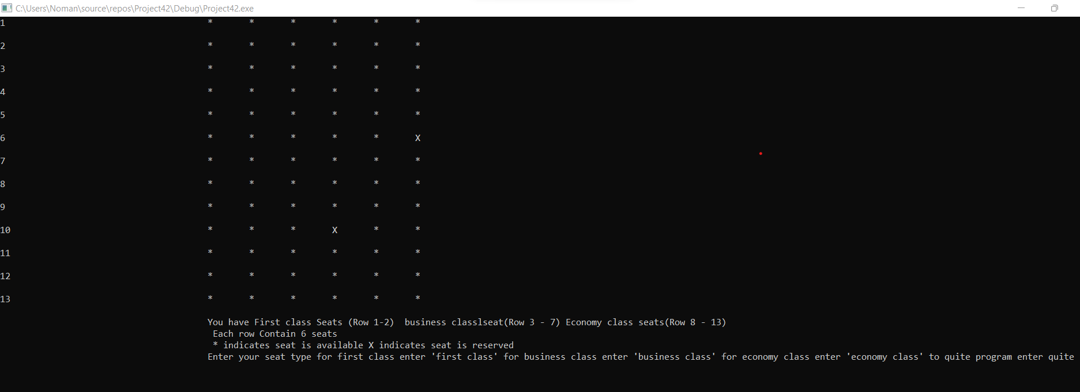

Task #4:

#include<iostream>

#include<string>

using namespace std;

int main()

{

double miles[5][7];

string jason, samantha, Ravi, Sheila, Ankit; /*Here we are taking Names*/

cout << "Enter the Names of Five Runners :";

cin >> jason >> samantha >> Ravi >> Sheila >> Ankit; /*Taking Input of Runners*/

cout << "Enter the Number of Miles each Person :";

for (int i = 0; i < 5; i++) /*Taking Input for each person */

{

for (int j = 0; j < 7; j++)

{

cin >> miles[i][j];

}

}

cout << "These are Miles for each person they run : ";

for (int i = 0; i < 5; i++) /*Displaying Miles of each Person */

{

for (int j = 0; j < 7; j++)

{

cout << miles[i][j] << " ";

}

}

cout << endl;

double sum=0, avg;

for (int i = 0; i < 5; i++) /* Finding Average and sum Runners */

{

for (int j = 0; j < 7; j++)

{

sum += miles[i][j];

}

}

for (int i = 0; i < 5; i++)

{

for (int j = 0; j < 7; j++)

{

avg = sum / 5;

}

}

cout << "The average of each day is : " << avg << " ";

cout << endl;

system("pause");

return 0;

}

Output:

